**SUPPLY CHAIN MANAGEMENT**

**AT**

**Deepak Spinners Limited**

A PROJECT REPORT SUBMITTED TO

DEEN DAYAL UPADHYAYA COLLEGE, UNIVERSITY OF DELHI IN PARTIAL FULFILLMENT FOR THE DEGREE OF

BACHELOR OF SCIENCE IN MATHEMATICAL SCIENCES

By

Disha Pattnaik

(20015587009)

(20MTS5708)

Under the supervision of

Dr. Veena Jain

(Associate Professor)

DEPARTMENT OF OPERATIONAL RESEARCH

DEEN DAYAL UPADHYAYA COLLEGE UNIVERSITY OF DELHI

NEW DELHI-110078 MAY 2023

**DECLARATION**

I hereby declare that the project report entitled “Supply Chain Management at Deepak Spinners Limited” is being submitted to the Department of Operational Research, Deen Dayal Upadhyaya College, University of Delhi 110078 in partial fulfillment of the requirement for the award of the degree of Bachelor of Science in Mathematical Sciences. I have prepared this report under the guidance and supervision of Dr. Veena Jain, Associate Professor, Deen Dayal Upadhyaya College, University of Delhi, New Delhi-11078

The project is based on my original research and has not been submitted for the award of any degree or diploma from any other university or institution to the best of my knowledge.

Place: New Delhi Disha Pattnaik

Date: 15/04/2023 20MTS5708

**CERTIFICATE**

I hereby certify that the Project titled ” Supply Chain Management at Deepak Spinners Limited ” which is submitted by Disha Pattnaik (20MTS5708), for the fulfilment of the requirements for awarding of the degree of Bachelor of Science (B.Sc.) Mathematical Sciences is a record of the project work carried out by the student under my guidance and supervision. To the best of my knowledge, this work has not been submitted in any part or fulfilment for any Degree or Diploma to this University or elsewhere.

Place: New Delhi Dr. VEENA JAIN

Date: 15/04/2023 Associate Professor

Deen Dayal Upadhyaya College University of Delhi

NEW DELHI-110078

**ABSTRACT**

The transportation and logistics industry plays a vital role in the textile industry, with effective supply chain management being crucial to the success of their businesses. This project aimed to solve a transportation problem for a company by using sensitivity analysis and sales forecasting using SARIMA.

The transportation problem was addressed by optimizing the allocation of goods from two warehouses to various retail stores. The project team used sensitivity analysis to identify the optimal solution to the transportation problem by varying the constraints and analyzing the impact on the objective function.

In addition to the transportation problem, the project team also implemented a sales forecasting model using SARIMA. Historical sales data was analyzed, and the SARIMA model was used to predict future sales trends. This allowed the company to make informed decisions about production levels, inventory management, and marketing strategies.

The project team integrated the transportation optimization and sales forecasting models to develop a comprehensive supply chain management system. The system provided valuable insights into future sales trends and optimized the allocation of goods from warehouses to retail stores.

Overall, the project aimed to address the challenges associated with transportation and supply chain management in the logistics industry, and to provide our company with the tools necessary to optimize profitability and stay competitive in the market.

**ACKNOWLEDGEMENT**

I would like to express my heartfelt thanks to Dr. Veena Jain for providing me with valuable guidance, support, and encouragement throughout the project. Her expertise and knowledge have been instrumental in shaping the project's direction and helping me to achieve the desired outcome.

I would also like to extend my gratitude to Mr. Rohit, Sales Head, Deepak Spinners Limited who helped me throughout the project. His insights and guidance were essential in the successful completion of the project.

Finally, I would like to express my appreciation to my family and friends for their unwavering support and encouragement. Their constant support, motivation, and understanding have been instrumental in helping me to complete this project successfully.

**Disha Pattnaik**

##### B.Sc. Mathematical Science Deen Dayal Upadhyaya College

University of Delhi NEW DELHI-110078

##### College Roll no.- 20MTS5708

##### Examination Roll no.- 20015587009

# Contents

### **Title Page No.**

List of Table v

List of Figures vi

1. Introduction to Operations Research 1
   1. Introduction 1
   2. History 1
   3. Features of Operation Research…………………………………………………………………2
   4. Scientific Method in Operations Research 2
   5. Advantages and Limitations of Operations Research 2
   6. Applications of Operations Research 3
   7. Operation Research Techniques 5
2. Supply Chain Management 6
   1. Introduction 6
   2. Supply chain Management 6
   3. How does Supply Chain Management works? 7
3. Transportation Problem and Sensitivity Analysis 16
   1. Transportation Problem 16
   2. Sensitivity Analysis 16
4. Supply Chain Planning and Forecasting 22
   1. What is Supply Chain Forecasting 22
   2. Understanding SARIMA 24
   3. What makes supply chain forecasting difficult?................................................28
5. Company Introduction and Problem Description 25
   1. Company Introduction……………………………………………………..
   2. Problem Description…………………………………………………………
6. Solution Methodology 26
7. Data Analysis and Results 35
8. References 36
9. Appendix 37
   1. Raw dataset **37**

Code for transportation problem and forecasting **38**

# **List of Table**

### **S. No Table Page No.**

#### 2.1 Return Analysis…………………………………………….

#### 7.1 Top 5 Destination with corresponding cost…………….

#### 7.2 Bottom 5 Destination with corresponding cost………...

#### 7.3 Optimal Shipping Routes…………………………………

#### 7.4 Sensitivity Analysis Result……………………………….

#### 7.5 Top 5 sales of the train data………………………………

#### 7.6 Top 5 sales of the test data………………………………..

# **List of Figures**

### **S. No Figure Page No.**

#### 2.1 Supply Chain……………………………………………….

#### 2.2 Supply Chain Forecasting…………………………………

#### 7.1 Optimal Status and Solution……………………………...

#### 7.2 Model Summary…………………………………………….

#### 7.3 RMSE Calculated……………………………………………

#### 7.4 Actual vs Forecasted sales………………………………….

**Chapter - 1 Introduction to Operations Research**

#### Introduction

Operations research, abbreviated as OR, is a discipline concerned with the development and implementation of advanced analytical tools for better decision-making. It is sometimes considered a branch of the mathematical sciences.

Operations research finds optimal or near-optimal solutions to complicated decision-making problems by combining tools from other quantitative sciences including as modelling, statistics, and optimization. Operations research interacts with many other fields, including industrial engineering, due to its emphasis on practical applications. It focuses on determining the maximum (of profit, performance, or yield) or minimum values of some real-world objective (of loss, risk, or cost).

With Data Science on the horizon of being the next big thing, the use of Operations Research is ever increasing, owing to the extensive use of Operations Research techniques in Data Analysis.

#### History

McClosky and Trefthen coined the term "Operational Research" in 1940 in a small town in the United Kingdom called Bowdsey. This new science came as a result of research into military operations during WWII. There were strategic and tactical problems that were so complex that expecting adequate solutions from individuals or specialists was unrealistic. As a result, military leaders convened scientists from various disciplines and organized them into teams to help solve strategic and tactical problems, i.e., to discuss, evolve, and suggest ways and means to improve the execution of various military projects. They proposed certain approaches that demonstrated remarkable progress because of their collaborative efforts, experience, and deliberations. This new method of studying the system's operations in a systematic and scientific manner was known as Operations Research or Operational Research (abbreviated as O.R.).

The success of military teams drew the attention of industrial managers looking for solutions to their problems immediately after the war which boomed its growth. The critical economic situation in the United Kingdom necessitated a drastic increase in production efficiency as well as the creation of new markets. The nationalization of a few key industries expanded the potential field for OR. As a result, OR quickly spread from military to government, industrial, social, and economic planning.

India was one of the first countries to use O.R. The first operational research unit, known as the Regional Research Laboratory, was established in Hyderabad in 1949. Simultaneously, an additional unit was established in the Defense Science Laboratory to address the Stores, Purchase, and Planning issues. Today, the use of O.R. techniques has spread from the army to a diverse range of departments at all levels. The next few decades saw many advancements in the field, especially due to simultaneous advancements in computer science technology that allowed solving complex problems with just a few clicks.

#### Features of OR

* **Making Decisions:**One of the basic uses of OR is to obtain optimum results to problems. This is all for the purpose of making smart and informed decisions for the organization. Decision making takes place in the following steps:
  + 1. Problem definition and decision of criteria
    2. Exploring alternatives
    3. Deciding models and parameters
    4. Solving model and choosing optimum solution
* **Scientific Approach*:*** For solving problems using OR, we employ scientific techniques to facilitate a fixed formal process.
* **Aim:**The purpose of OR lies in finding the best possible solutions for the given problem, keeping in mind the organization’s goals. The pre- definition of these goals is crucial to the problem-solving process.
* **Inter-Disciplinary Approach:**The problems in OR may sometimes fall into more than one disciplines. For this, it is necessary to take into accounts opinions of all the people in the respective fields to reach to a practical and feasible solution for the problem. Often, people with knowledge about multiple domains are chosen for this purpose.
* **Computerization:**OR problems can require building of complex models, solving which is not feasible for humans. Use of digital computers can help with such problems, giving us error-free solutions within seconds.

#### Scientific Method in Operations Research

The scientific method is the most important feature of Operations Research. It is divided into three phases:

**Judgement Phase:** This phase consists of the following steps: (i) identifying the real-life problem, (ii) selecting an appropriate goal and the values of various variables related to the goals, (iii) selecting an appropriate scale of measurement, and (iv) formulating an appropriate model of the problem, abstracting the essential information so that a solution at the decision-goal makers can be sought.

**Research Phase:** This is the largest and longest of the two phases. However, the remaining two are equally important because they serve as the foundation for a scientific method. This phase includes: (i) observations and data collection to gain a better understanding of the problem, (ii) hypothesis and model formulation, (iii) observation and experimentation to test the hypothesis with additional data, (iv) analysis of the available information and hypothesis verification using pre-established measures of effectiveness, (v) predictions of various results from the hypothesis, and (vi) generalization of the results and conjectures.

**Action Phase:** This phase consists of making recommendations for the decision-making process by those who first posed the problem for consideration, or by anyone in a position to make a decision affecting the operation in which the problem occurred.

#### Advantages and Limitations of Operations Research

**Advantages:**

**Better Systems:** Often, an O.R. approach is initiated to analyze a specific decision-making problem, such as the best location for factories, whether to open a new warehouse, and so on. It also aids in the selection of cost-effective modes of transportation, job sequencing, production scheduling, and the replacement of old machinery, among other things.

**Better Control:** The management of large organizations recognizes that providing continuous executive supervision to every routine task is a difficult and costly endeavor. An O.R. approach may provide an analytical and quantitative foundation for the executive to identify the problem area. The most used applications in this category are those for production scheduling and inventory replenishment.

**Better Decisions:** O.R. models aid in decision making and reduce the possibility of making incorrect decisions. The O.R. approach provides the executive with a better understanding of how he makes decisions.

**Better Coordination:** An operations-research-oriented planning model aids in the coordination of a company's various divisions.

**Limitations:**

**Reliance on an electronic computer:** O.R. techniques attempt to find an optimal solution while taking all factors into account. These factors are enormous in modern society and quantifying them and establishing relationships between them necessitate voluminous calculations that can only be handled by computers.

**Non-Quantifiable Factors:** Only when all the elements related to a problem can be quantified can O.R. techniques provide a solution. Quantification is not possible for all relevant variables. Unquantifiable factors have no place in O.R. models.

**Money and Time Expenses:** When the basic data is subject to frequent changes, incorporating it into the O.R. models is an expensive endeavor. Furthermore, a reasonably good solution now may be preferable to a perfect O.R. solution later.

**Implementation:** Decision implementation is a delicate task. It must account for the complexities of human relationships and behavior.

#### Applications of Operations Research

Aside from scientific advancement, O.R. is primarily concerned with the techniques of applying scientific knowledge. It provides an understanding that provides the expert/manager with new insights and capabilities to determine better solutions to his decision-making problems quickly, competently, and confidently. O.R. has successfully entered many different areas of research in recent years, including Defence, Government, Service Organizations, and Industry. We briefly describe some O.R. applications in management functional areas:

###### **Project Allocation and Distribution:**

* 1. Optimal project resource allocation, including men, materials, machines, time, and money.
  2. Identifying and deploying the appropriate workforce.
  3. Project planning, management, and control.

###### **Production and Facility Planning:**

* 1. Choosing the size and location of the factory.
  2. Estimate the number of facilities needed.
  3. Forecasting for various inventory items, as well as calculating economic order quantities and reorder levels.
  4. Scheduling and sequencing of production runs through proper machine allocation.
  5. Transportation loading and unloading; and (vi) Warehouse location determination.

(vii) Decisions on maintenance policy.

###### **Program Decisions:**

* 1. What, when, and how to buy to reduce procurement costs.
  2. Policies for bidding and replacement.

###### **Marketing:**

* 1. The timing of product introduction.
  2. Advertising media selection.
  3. Product mix selection
  4. Customer preferences for product size, colour, and packaging.

###### **Organizational Behavior:**

* 1. Personnel Selection, Determination of Retirement Age and Skills
  2. Job assignment and recruitment policies.
  3. Employee recruitment.
  4. Training programme scheduling

###### **Finance:**

* 1. Capital needs, cash flow analysis
  2. Credit policies, credit risks, and so on.
  3. Investment choice.
  4. The company's profit plan.

###### **Research and Development:**

* 1. Product launch planning
  2. Oversight of R&D projects.
  3. Identification of research and development priorities.
  4. Project selection and budget preparation.
  5. Development project dependability and control as a result, it is possible to conclude that operation research can be widely used in management decisions and can also be used as a corrective measure.

#### Some Operation Research Techniques

**Linear Programming:** Linear Programming (LP) is a mathematical technique for allocating a fixed number of resources to meet a number of demands in such a way that some objective is optimized while other defined conditions are also met.

**Transportation Problem:** The transportation problem is a subset of linear programming problems in which the goal is to minimize the cost of distributing a product from multiple sources to multiple destinations.

**Queuing Theory:** Queuing theory helps in estimating number of people waiting in queue, the expected waiting time in the queue, the server's expected idle time, and so on. Thus, this theory can be applied in situations where decisions must be made to minimize the length and duration of the queue while spending the least amount of money.

**Inventory Control Models:** It is concerned with the acquisition, storage, and handling of inventories in order to ensure inventory availability whenever needed while minimizing waste and losses. It assists managers in determining the best reordering time, level, and quantity.

**Nonlinear Programming:** These methods can be used when the optimization problem or some of the constraints are not linear. Non-linearity can be created by factors such as a discount on the purchase price of large quantities.

**Network Scheduling-PERT and CPM:** A network scheduling technique is used to plan, schedule, and monitor large projects. Such large projects are common in the fields of construction, maintenance, computer system installation, R&D design, and so on. Projects undergoing network analysis are divided into individual tasks, which are then arranged in a logical sequence by determining which activities should be performed concurrently and which should be performed sequentially.

**Game Theory:** It is used to make decisions in conflicting situations with one or more opponents (i.e., players). In game theory, we consider two or more people with different goals, each of whose actions influences the game's outcomes. The game theory provides solutions to such games if each player wishes to maximize his profits while minimizing his losses.

**Simulation:** It is a technique that entails creating a model of a real-world situation and then conducting experiments on it. When it is too dangerous, difficult, or time consuming to conduct a real study or experiment to learn more about a situation, simulation is used.

**Chapter - 2 Supply Chain Management**

#### Supply Chain

#### The supply chain is a network of organizations, individuals, and activities involved in the creation and delivery of a product or service to the end consumer. It includes all the steps involved in the production and distribution of goods and services, from the sourcing of raw materials to the delivery of finished products.

#### The supply chain can be divided into several key stages, including:

#### Procurement: The process of identifying and selecting suppliers, negotiating contracts, and acquiring the necessary raw materials and supplies for production.

#### Production: The process of transforming raw materials and supplies into finished products through manufacturing, assembly, or other production processes.

#### Transportation: The movement of goods and materials from one location to another, including the shipping, handling, and storage of products at various points in the supply chain.

#### Warehousing: The storage and management of goods and materials at various points in the supply chain, including distribution centers, warehouses, and other storage facilities.

#### Distribution: The delivery of products to customers, including the management of logistics, transportation, and delivery networks.

#### Overall, the supply chain is a complex and interconnected system that involves multiple stakeholders and activities. Efficient supply chain management is essential for businesses to ensure that they can meet customer demands, minimize costs, and remain competitive in the marketplace.

#### Figure 2.1: Supply Chain

#### Supply Chain Management (SCM)

Supply chain management is the management of a product’s or service’s full manufacturing cycle, from raw materials through ultimate delivery to the customer. A business establishes a network of suppliers (”links in the chain”) to transport products from raw material suppliers to organisations that sell products and services.

Suppliers strive to build and operate supply networks that are as efficient and cost-effective as feasible through supply chain management (SCM). Supply chains encompass every- thing from manufacturing to product development as well as the information systems required to coordinate these activities.

SCM seeks to centrally regulate or link a product’s production, shipment, and distribution. Companies may decrease costs and deliver items to customers faster by optimizing’s the supply chain. Internal inventories, internal manufacturing, distribution, sales, and business vendor stocks are all under tighter supervision. SCM is built on the principle that practically every product that reaches the market is the result of the work of many different elements that make up a supply chain. Although supply chains have been around for a long time, most businesses have only lately recognised them as a valuable addition to their operations.

#### How does Supply Chain Management works?

#### Planning

#### Planning is a critical component of supply chain management (SCM), as it helps to ensure that the supply chain is efficient, cost-effective, and responsive to customer demands. Effective planning involves developing strategies and processes to manage the flow of goods and services through the supply chain, from the point of origin to the point of consumption.

The practice of correctly arranging the course of a material or a product first from feedstock stage to the end consumer is known as supply chain planning. Supply fore- casting, sales forecasting, production scheduling, distribution management, logistics, and sales forecasting are all part of this process.

#### Overall, planning is a critical component of SCM, as it helps to ensure that the supply chain can operate efficiently and effectively, while meeting the needs of customers and minimizing costs. Effective planning requires collaboration and coordination among all participants in the supply chain, as well as the use of technology and data analytics to support decision-making and improve visibility across the supply chain.

The beating heart of supply chain planning is supply chain forecasting. Businesses analyze previous and present supply to estimate future demand using a combination of historical facts, data, and a little intuition. Understanding how to forecast your supply chain accurately will enhance your relationship with its suppliers and ensure that you are scheduling the correct amount of cargo to minimize excessive costs. You’ll also know how to prepare for both expected and unforeseen disruptions.

Figure 2.3: Supply Chain Forecasting

#### Sourcing

The sourcing process encompasses all activities centered on locating and explore potential suppliers, along with selecting and working with the best value provider. Establish mechanisms to plan and control supplier relationships between the buyer and the supplier on what will be acquired and the contract conditions at the conclusion of the sourcing process. Sourcing specialists assess the supply market, devise, and implement a plan, negotiate contract conditions, and draught a contract with suppliers. Ordering, receiving, inventory management, and supplier payments are all important procedures.

Consider the following sourcing strategies:

* + - * **Outsourcing:** Using external vendors to offer services and goods that have been previously delivered inside.
      * **Insourcing:** Offloading a task to someone within the company.
      * **Near sourcing:** To save time and money, a company locates certain operations near where its final goods are sold. Integrating vertically. Merging enterprises in the same industry that are at various phases of production and/or distribution. Back- ward integration occurs when a firm buys its input provider; forward integration occurs when a company acquires companies in its distribution chain.
      * **Few or many suppliers:** For commodity items, a many-supplier strategy is prevalent, and purchasing is often based on price. Even if other suppliers provide com- parable items. Purchases made with only one supplier are known as sole-source procurement. Single-supplier partnerships might be risky, but they can also be profitable.
      * **Joint ventures:** A joint venture is a commercial company formed by two or more partners that has shared ownership, rewards and risks, and governance.
      * **Virtual business:** A network of independent businesses (suppliers, consumers, and rivals) connected by information technology to share talents, costs, and market access.

#### Sourcing is a critical component of supply chain management (SCM), as it involves identifying, selecting, and managing suppliers to ensure that the necessary materials and resources are available to support production and delivery. Effective sourcing can help to ensure that the supply chain is able to operate efficiently and effectively, while minimizing costs and maintaining quality.

#### Overall, sourcing is a critical component of SCM, as it helps to ensure that the necessary materials and resources are available to support production and delivery. Effective sourcing requires collaboration and coordination among all participants in the supply chain, as well as the use of technology and data analytics to support decision-making and improve visibility across the supply chain.

#### Inventory

#### Inventory is a critical component of supply chain management (SCM), as it involves managing the stock of raw materials, work-in-progress (WIP), and finished goods to ensure that products are available when needed, while minimizing excess inventory and associated costs. Effective inventory management can help to ensure that the supply chain operates efficiently and effectively, without experiencing stockouts or excess inventory.

#### Some of the key aspects of inventory management in SCM include:

#### Inventory optimization: This involves determining the appropriate levels of inventory for each stage of the supply chain, based on factors such as demand variability, lead times, and supplier performance. Effective inventory optimization can help to ensure that products are available when needed, while minimizing excess inventory and associated costs.

#### Inventory tracking and visibility: This involves tracking inventory levels and movements throughout the supply chain, to ensure that products are available when needed and to identify potential issues or bottlenecks. Effective inventory tracking and visibility can help to ensure that the supply chain operates efficiently and effectively, without experiencing stockouts or excess inventory.

#### Inventory replenishment: This involves replenishing inventory levels as needed, to ensure that products are available when needed and to avoid stockouts. Effective inventory replenishment can help to ensure that the supply chain operates smoothly and responds effectively to unexpected events.

#### Safety stock management: This involves maintaining a buffer of inventory to protect against unexpected demand spikes, supplier disruptions, or other issues that could impact the supply chain. Effective safety stock management can help to ensure that the supply chain is able to operate smoothly and respond effectively to unexpected events.

#### Inventory cost management: This involves managing the costs associated with holding inventory, such as storage, handling, and obsolescence. Effective inventory cost management can help to minimize inventory-related costs, while ensuring that products are available when needed.

#### Overall, inventory management is a critical component of SCM, as it helps to ensure that products are available when needed, while minimizing excess inventory and associated costs. Effective inventory management requires collaboration and coordination among all participants in the supply chain, as well as the use of technology and data analytics to support decision-making and improve visibility across the supply chain.

#### Production

Many individuals confuse the terms manufacturing and production. As a result, while discussing industry processes, these terms are often interchanged. Manufacturing and production, while having identical basics, are two distinct processes. So, what actually is the gap between manufacturing and production?

#### What Does Manufacturing Actually involve?

Manufacturing is the process of converting raw materials or parts into completed things using tools, human labour, equipment, and chemical processes.

Manufacturing enables companies to sell completed goods for more than the cost of the raw materials required. Large-scale manufacturing enables the mass production of items employing assembly line procedures and technical innovation as primary assets. Manufacturers may take benefits of economies of scale by using efficient production tech niques to produce more units for less money.

Common processes involved in manufacturing:

* + - * Fabrication
      * Prefabrication
      * Manufacturing quickly
      * Manufacturing agility
      * Manufacturing lean
      * Manufacturing flexibility

#### Production and it’s aspects

#### Production is an important aspect of supply chain management (SCM) as it involves the actual manufacturing or assembly of products that are needed to meet customer demand. Production in SCM encompasses a range of activities, including planning, scheduling, sourcing of raw materials, and actual manufacturing or assembly.

#### Effective production management is essential for ensuring that products are produced efficiently, cost-effectively, and to the desired level of quality. This involves a number of considerations, such as optimizing production processes, minimizing waste and downtime, and ensuring that sufficient inventory is available to meet customer demand.

#### One important aspect of production in SCM is capacity planning. Manufacturers need to carefully manage their production capacity to ensure that they are able to meet customer demand without overproducing and creating excess inventory or underproducing and creating stockouts. Effective capacity planning requires careful consideration of factors such as production lead times, raw material availability, and demand forecasts.

#### Another key aspect of production in SCM is quality control. Manufacturers need to ensure that the products they produce meet the required quality standards, and that any defects or issues are identified and addressed quickly. Quality control involves a range of activities, such as inspection, testing, and continuous improvement initiatives.

#### To optimize production in SCM, manufacturers can use a range of tools and techniques, such as lean manufacturing, Six Sigma, and automation. These methodologies aim to eliminate waste, reduce cycle times, and improve quality, which can result in significant cost savings and improved customer satisfaction.

#### Overall, production is a critical component of SCM, and manufacturers must work closely with their supply chain partners to ensure that they can produce products efficiently, cost-effectively, and to the required level of quality. Effective production management can help to ensure that customer demand is met in a timely and efficient manner, while also minimizing costs and improving quality.

#### Methods of Production:

**Job Creation-** A single product is produced at a time in job manufacturing. Businesses that employ job production create one-of-a-kind, non-standard goods that are manufactured to order each time. Shipbuilding and bridge construction are examples of job production since each ship is built to the customer’s specifications.

Job Production Characteristics

* + - * The product is made to the customer’s specifications.
      * Multipurpose machinery is used in conjunction with skilled, adaptable labour.
      * Workers are driven to complete a wide range of duties.
      * Short manufacturing runs result in higher unit costs.

#### Production in batches

It entails producing many variations of the same fundamental product in batches. Producing soap in various scents, for example. There is a recurrence of production in contrast to job production.

Batch production characteristics

* + - * Suitable for a large range of almost identical commodities that may be produced using the same technology in various locations.
      * More diversity for employees means higher job satisfaction.
      * Unit costs are higher when manufacturing runs are short.
      * When switching between batches, supplies prove to be ideal at times.

#### Flow production

It includes high production. When one procedure is accomplished, the job continues without interruption to the next. It’s a continual process in which pieces go from one stage to the next until they’re finished. Chocolate bars production process is an example of flow production.

#### How technology has transformed production processes

Technology advancements can help cut expenses and increase product quality.

**Automation:** is the use of computer-controlled technology to produce goods.

**Mechanization:** Workers run machines to produce goods.

**CAD stands for computer-aided design:**which uses 3D drawing software to create new items.

**Electronic point of sale** :When an item’s barcode is read once it is sold, stock records are automatically changed at the electronic point of sale. Consider supermarket stock.

**EFTPOS (Electronic Funds Transfer at Point of Sale):** Bank-connected cash reg- isters (The customer’s card is swiped, and money is immediately transferred from the customer’s bank account).

#### Transportation and Logistics

#### Transportation and logistics play a crucial role in supply chain management (SCM) as they are responsible for the movement of goods and materials between different stages of the supply chain. Transportation involves the physical movement of goods, while logistics involves the planning, coordination, and management of that movement.

#### Effective transportation and logistics management is essential for ensuring that products are delivered to customers on time and at the lowest possible cost. This involves a number of considerations, such as optimizing transport routes, selecting the most appropriate mode of transport (e.g. road, rail, sea, air), and managing inventory levels to ensure that sufficient stock is available to meet customer demand.

#### One important aspect of transportation and logistics in SCM is freight management. This involves the management of the transportation and delivery of goods, including the negotiation of contracts with carriers, the tracking of shipments, and the management of freight costs. Effective freight management requires careful consideration of factors such as transportation mode, delivery schedules, and transit times.

#### Another key aspect of transportation and logistics in SCM is inventory management. This involves the management of inventory levels to ensure that sufficient stock is available to meet customer demand, without creating unnecessary inventory holding costs. Effective inventory management requires careful coordination between different stages of the supply chain, including manufacturers, distributors, and retailers.

#### To optimize transportation and logistics in SCM, companies can use a range of tools and techniques, such as transportation management systems (TMS), warehouse management systems (WMS), and supply chain visibility platforms. These technologies can help to improve visibility and coordination across the supply chain, reduce costs, and improve customer satisfaction.

#### Overall, transportation and logistics are critical components of SCM, and companies must work closely with their supply chain partners to ensure that they can deliver products to customers efficiently and cost-effectively. Effective transportation and logistics management can help to ensure that products are delivered to customers on time, at the lowest possible cost, and with the highest level of quality.

The majority of modes of transportation are designed to move either passengers or freight, although they may transport both. A truck, for example, may move any type of cargo, but a passenger plane does have a belly hold that can accommodate luggage and passengers. Each mode is distinguished by a set of technical, organizational, and eco- nomic qualities. Speed limitations, safety requirements, and operating hours are examples of technical characteristics, whereas technical aspects include factors like horsepower, capacity, and driving technologies.

#### Return of Goods (Reverse Logistics)

Reverse logistics corresponds to tracking the products’ lifecycle after they reach the final user. This might include things like how your product could be reused, how it can be properly disposed of after usage, and any other way your expired product can be useful.

The return of items from the end customer to the producer is the reverse logistics that has the greatest influence on supply chains. The practice of managing items that are returned to an organization is known as returns management, sometimes known as reverse logistics. When dealing with returns, quality control is crucial since faults in the item must be recognized to make improvements to production methods, building materials, or vendors.

Returns have an impact on the supply chain because they increase holding costs by necessitating more storage space and personnel. Not only will returned products take up space, but their value may degrade, reducing their marketability.

To overcome these concerns, an effective returns management mechanism must be implemented. Creating techniques to swiftly recoup value from returned items via resale or secondary markets might be part of this process.

Effective procedures will also enable businesses to provide better customer service, since returns will be handled fast and replacements will be supplied immediately.

#### Four essential supply chain metrics that aid in identifying the flow of returned products into the supply chain :

1. **Quantity:** Are the same goods being returned repeatedly? Is this a widespread occurrence? If you answered yes to either of these questions, you’re likely dealing with more than a few malfunctioning units. You might have to consider either recall or maybe a complete revamp of the manufacturing process.
2. **Percentage of Sales:** How much of your revenue is lost due to product returns? How many of these items can you reintroduce into your production process using reverse logistics?
3. **Product Return Condition:** Is the product malfunctioning after a certain operation? Can you see any failure trends among the returned goods? Quality assurance (QA) and failure repetition are critical in this situation. We need to figure out what’s wrong so that we can adapt and fix it before it happens again.
4. **Financial Value:** Its firm might be losing huge amounts of money in potential value if we don’t monitor and manage reverse logistics. Take, for example, defective devices that are returned to the maker. Electronics sold in secondary marketplaces” represent an estimated $ 15 billion (sales) in the United States,” according to” Recovering Lost Profits by Improving Reverse Logistics.” By adopting reverse logistics, these electronic enterprises can transform product failure into fresh revenues.

|  |  |
| --- | --- |
| Reason of return | Percentage of returns (%) |
| Product defective | 60 |
| Poor performance-does not meet user expectation | 15 |
| Improper marketing of tool | 10 |
| Buyer remorse | 10 |
| Tool used for a specific purpose, then returned | 5 |

Table 2.1: Return Analysis

**Chapter - 3 Transportation Problem and Sensitivity Analysis**

1. **Transportation Problem**

The transportation problem is a classic optimization problem in operations research that deals with determining the least-cost way to transport goods from a set of sources to a set of destinations. It is a linear programming problem that can be used to solve a wide range of real-world logistics and supply chain problems, including transportation planning, inventory management, and network design.

In the transportation problem, the objective is to minimize the total cost of transporting a set of goods from a set of sources to a set of destinations, subject to various constraints such as capacity limits and demand requirements. The problem involves determining the optimal shipping quantities from each source to each destination, given the unit transportation costs and the availability and demand of goods.

The transportation problem can be formulated as a linear programming problem with a set of decision variables that represent the amount of goods shipped from each source to each destination. The objective function is typically the total transportation cost, which is the sum of the unit transportation costs multiplied by the shipping quantities. The constraints in the problem include capacity constraints, which limit the amount of goods that can be shipped from each source, and demand constraints, which specify the required amount of goods at each destination.

The transportation problem can be solved using a variety of algorithms, including the simplex method, the transportation simplex method, and the network flow algorithm. These algorithms are designed to find the optimal solution to the problem, which is the set of shipping quantities that minimize the total transportation cost while satisfying all of the constraints.

The transportation problem has numerous applications in logistics and supply chain management, including determining the optimal routing of goods between warehouses and retailers, determining the optimal allocation of inventory between production facilities and warehouses, and optimizing the distribution of goods across a network of suppliers and customers. By solving the transportation problem, companies can optimize their logistics and supply chain operations, reduce costs, and improve customer service.

* + 1. **Types of Transportation Problem:**

The transportation problem has several variations, depending on the specific constraints and requirements of the problem. For example, the problem can be extended to include multiple modes of transportation, such as air, sea, and land transport, with different costs and capacity constraints for each mode. The problem can also be modified to include time constraints, such as delivery deadlines, which can significantly impact the optimal shipping quantities and routes.

Another variation of the transportation problem is the transshipment problem, which involves intermediate locations, called transshipment points, where goods can be temporarily stored and transferred between different modes of transportation. The transshipment problem adds additional complexity to the optimization problem, as it involves determining the optimal routing of goods through multiple stages, with different costs and capacity constraints at each stage.

To solve the transportation problem, a variety of software tools and algorithms are available, such as Excel Solver, LINGO, Python, R and Gurobi. These tools use a combination of linear programming and optimization techniques to find the optimal shipping quantities that satisfy all constraints and minimize the total transportation cost.

In practice, the transportation problem is a critical component of logistics and supply chain management, as it helps companies optimize their transportation and distribution networks to minimize costs, improve efficiency, and enhance customer service. By solving the transportation problem, companies can make data-driven decisions on inventory allocation, shipping routes, and delivery schedules, leading to more effective supply chain management and increased profitability.

* + 1. **Types of Transportation Problem:**

There are several types of transportation problems, each with its own set of constraints and requirements. The most common types of transportation problems are:

* + - 1. **Basic transportation problem:** This is the simplest form of the transportation problem, which involves determining the optimal shipping quantities from a set of sources to a set of destinations, subject to capacity and demand constraints.
      2. **Transshipment problem:** This type of transportation problem involves intermediate locations, called transshipment points, where goods can be temporarily stored and transferred between different modes of transportation. The transshipment problem adds additional complexity to the optimization problem, as it involves determining the optimal routing of goods through multiple stages, with different costs and capacity constraints at each stage.
      3. **Multi-commodity transportation problem:** This type of transportation problem involves multiple types of goods or commodities that need to be shipped from multiple sources to multiple destinations, subject to capacity and demand constraints for each commodity.
      4. **Time-constrained transportation problem:** This type of transportation problem involves delivery deadlines or time constraints that must be met in addition to capacity and demand constraints. The objective is to minimize the total transportation cost while ensuring that all goods are delivered on time.
      5. **Multi-objective transportation problem:** This type of transportation problem involves multiple conflicting objectives, such as minimizing transportation cost and maximizing customer satisfaction. The challenge is to find a trade-off between the different objectives and identify the optimal shipping quantities that satisfy all constraints.
      6. **Stochastic transportation problem:** This type of transportation problem involves uncertain demand or supply, where the quantities of goods to be shipped are not known with certainty. The objective is to minimize the expected transportation cost while accounting for the uncertainty in demand or supply.

Each type of transportation problem requires different optimization techniques and algorithms to find the optimal shipping quantities that satisfy all constraints and minimize the total transportation cost. By understanding the specific constraints and requirements of the transportation problem, companies can make data-driven decisions on inventory allocation, shipping routes, and delivery schedules, leading to more effective supply chain management and increased profitability.

* 1. **Sensitivity Analysis**

Sensitivity analysis in transportation problem is a method used to evaluate how sensitive the optimal solution is to changes in the parameters of the problem. In the transportation problem, the sensitivity analysis is used to determine the impact of changes in the transportation costs, supply and demand quantities, and capacity constraints on the optimal shipping quantities and total transportation cost.

Sensitivity analysis involves computing the dual values, also known as shadow prices, of the constraints and the objective function. The dual values represent the change in the optimal objective value for a unit change in the right-hand side of the constraint or the objective coefficient. By analyzing the dual values, we can determine the impact of changes in the parameters on the optimal solution.

* + 1. **Various Categories**

The sensitivity analysis in transportation problem can be divided into two categories: sensitivity analysis of the objective function and sensitivity analysis of the constraints.

* + - 1. **Sensitivity analysis of the objective function:** The sensitivity analysis of the objective function involves evaluating how the optimal shipping quantities and the total transportation cost change when the unit transportation cost changes. This analysis is important for companies to determine the impact of changes in transportation costs on their supply chain operations.
      2. **Sensitivity analysis of the constraints:** The sensitivity analysis of the constraints involves evaluating how the optimal shipping quantities and the total transportation cost change when the capacity constraints, supply or demand quantities change. This analysis is important for companies to determine the impact of changes in capacity constraints or supply and demand quantities on their supply chain operations.

The sensitivity analysis in transportation problem can be performed using various tools such as Excel Solver, LINGO, Python, R and Gurobi. These tools provide sensitivity reports that allow companies to analyze the impact of changes in the parameters on the optimal solution and make data-driven decisions on their supply chain operations.

Sensitivity analysis in transportation problem is an important tool that enables companies to evaluate the impact of changes in the transportation costs, supply and demand quantities, and capacity constraints on their supply chain operations. By performing sensitivity analysis, companies can identify the optimal shipping quantities and total transportation cost and make data-driven decisions to improve their supply chain performance.

In addition to evaluating the impact of changes in the transportation costs, supply and demand quantities, and capacity constraints, sensitivity analysis in transportation problem can also be used to identify the range of values within which the optimal solution remains valid. This range of values is called the range of optimality.

For example, if the capacity of a particular source increases or decreases by a certain amount, the optimal shipping quantities and total transportation cost may change. However, if the change in capacity is within the range of optimality, the optimal solution remains valid. If the change in capacity is outside the range of optimality, a new optimal solution needs to be computed.

The range of optimality can be determined by analyzing the shadow prices of the constraints. The shadow prices represent the change in the optimal objective value for a unit change in the right-hand side of the constraint. If the shadow price is positive, it indicates that the constraint is binding, and the optimal solution remains valid within a certain range of values. If the shadow price is zero, it indicates that the constraint is not binding, and the optimal solution remains valid for any value within the constraint.

Sensitivity analysis in transportation problem can also be used to identify the critical constraints or parameters that have the most significant impact on the optimal solution. By focusing on these critical constraints or parameters, companies can prioritize their efforts to improve their supply chain operations and optimize their transportation network.

Moreover, sensitivity analysis in transportation problem can be extended to multi-objective transportation problems, where the objective is to optimize multiple conflicting objectives, such as minimizing transportation cost and maximizing customer satisfaction. Sensitivity analysis can be used to identify the trade-off between the different objectives and the impact of changes in the parameters on the optimal solution.

In conclusion, sensitivity analysis in transportation problem is a powerful tool that enables companies to evaluate the impact of changes in the transportation costs, supply and demand quantities, and capacity constraints on their supply chain operations. By performing sensitivity analysis, companies can identify the range of optimality, the critical constraints or parameters, and the trade-off between conflicting objectives. This information can be used to optimize their transportation network, improve their supply chain performance, and increase their profitability.

**Chapter - 4 Supply Chain Planning and Forecasting**

Supply chain planning refers to the process of designing and optimizing a supply chain network to meet the demands of customers while minimizing costs and improving efficiency. Supply chain planning involves a series of interdependent processes, including demand planning, inventory planning, production planning, and transportation planning, among others.

1. **Demand planning** is the process of forecasting customer demand for a product or service. This information is used to determine the quantities of products that need to be produced or purchased from suppliers. Accurate demand planning is critical for efficient inventory management, as overstocking or understocking can lead to excess costs or lost sales, respectively.
2. **Inventory planning** involves determining the optimal inventory levels of each product in the supply chain network. The goal is to maintain enough inventory to meet customer demand while minimizing inventory holding costs. Inventory planning requires collaboration between different parts of the supply chain network, including suppliers, manufacturers, and distributors.
3. **Production planning** involves scheduling the production of goods in a way that maximizes efficiency and minimizes costs. Production planning considers factors such as available resources, production capacity, and production lead times to determine the optimal production schedule.

Transportation planning involves optimizing the movement of goods between different points in the supply chain network. This includes determining the best mode of transportation (e.g., truck, ship, air) and the most efficient routing to minimize transportation costs and lead times.

Other processes involved in supply chain planning include supplier selection and management, quality control, and risk management. Effective supply chain planning requires collaboration and communication between different stakeholders in the supply chain network, including suppliers, manufacturers, distributors, and retailers.

Advanced technologies such as artificial intelligence, machine learning, and big data analytics are increasingly being used to improve supply chain planning. These technologies can provide real-time insights into customer demand, inventory levels, production schedules, and transportation routes, enabling companies to make data-driven decisions and optimize their supply chain network.

In conclusion, supply chain planning is a critical process for ensuring the efficient and cost-effective movement of goods through the supply chain network. By optimizing processes such as demand planning, inventory planning, production planning, and transportation planning, companies can improve their supply chain performance and increase their competitiveness in the market.

The core of planning is forecasting. In addition, forecasting is so important to good planning that it is not an overstatement to say that the forecast’s validity and accuracy determine the plan’s success in major part.

1. **What is Supply Chain Forecasting**

Supply chain forecasting is the process of predicting future demand for a product or service in a supply chain network. Forecasting is a critical component of supply chain management because it helps companies plan and allocate resources efficiently to meet customer demand while minimizing costs.

Effective supply chain forecasting requires a comprehensive understanding of the market, including customer behavior, market trends, and competitor actions. It involves analyzing historical data and using statistical models, machine learning algorithms, and other analytical tools to forecast future demand accurately.

The forecasting process typically involves the following steps:

1. **Data collection:** Collecting relevant data from various sources, such as sales data, market data, and customer data.
2. **Data analysis:** Analyzing the data to identify patterns and trends that can help predict future demand.
3. **Forecast generation:** Generating a forecast using statistical models or other analytical techniques.
4. **Forecast evaluation:** Evaluating the accuracy of the forecast by comparing it to actual demand.
5. **Forecast adjustment:** Adjusting the forecast based on the evaluation results and incorporating additional data or insights.
6. **Types of Forecasting**

There are several types of forecasting methods used in supply chain management, including:

* + - 1. **Time-series forecasting:** This method uses historical data to predict future demand by identifying patterns and trends over time.
      2. **Causal forecasting:** This method identifies the relationship between demand and other factors such as economic indicators, competitor actions, and marketing campaigns.
      3. **Judgmental forecasting:** This method relies on expert opinions and insights to make predictions about future demand.
      4. **Collaborative forecasting:** This method involves collaboration between different stakeholders in the supply chain network, such as suppliers, manufacturers, and retailers, to improve the accuracy of the forecast.

Advanced technologies such as artificial intelligence, machine learning, and big data analytics are increasingly being used to improve supply chain forecasting. These technologies can provide real-time insights into customer behavior, market trends, and competitor actions, enabling companies to make more accurate predictions and optimize their supply chain operations.

Supply chain forecasting is a critical process for ensuring the efficient and cost-effective movement of goods through the supply chain network. By accurately predicting future demand, companies can plan and allocate resources efficiently, reduce inventory costs, and improve customer satisfaction.

1. **Quantitative forecasting methods**

Quantitative and qualitative approaches to supply chain forecasting are the most com- mon. Quantitative forecasting uses complicated algorithms and computer programs to anticipate future sales based on previous data.

* + - 1. **Moving average forecasting** is a straightforward form of predicting that uses previous averages. However, it treats all data identically and ignores the fact that more recent data may be a better predictor of future trends than data from three or five years ago — and it ignores seasonality and patterns.
      2. **Exponential smoothing:** takes into consideration both historical and present data, as well as seasonality. It’s perfect for making short-term projections because of this.
      3. **The auto-regressive integrated moving average (ARIMA):** is a forecasting approach that is noted for its accuracy, but it is also time-consuming and expensive. It’s best for predicting for up to 18 months.
      4. **MAPA (Multiple Aggregation Prediction Algorithm):** is a newer approach of quantitative forecasting that is particularly built for seasonality, making it ideal for companies who produce seasonal goods.
  1. **Understanding SARIMA**

1. **Overview**

Time-series data is data that has been indexed in such a way that the data points represent the number of changes occurring over time. For example, a unit of commodity sales for a specific date, week, month, or year, or a temperature change over time. As a result, one of the most significant disciplines of data analysis is forecasting future value based on the history of a time series. We have numerous models in forecasting that assist us produce predictions and forecast values to fulfil our future aspects based on the requirement of the circumstance. AR, MA, ARIMA, SARIMA, VAR, SARIMAX, and other models are examples.

SARIMA (Seasonal Autoregressive Integrated Moving Average) is a statistical model used for time-series forecasting. It is an extension of the ARIMA model, which stands for Autoregressive Integrated Moving Average.

The SARIMA model takes into account the seasonality of a time series, which is a regular pattern that repeats over a fixed period. For example, sales of winter clothes may increase every year during the winter season, while sales of summer clothes may decrease during the same period.

The SARIMA model consists of the following components:

1. **Seasonal differencing:** This involves subtracting the value of the time series at a particular season from the value at the same season in the previous year. Seasonal differencing removes the seasonality from the time series and makes it stationary.
2. **Autoregression:** This involves predicting future values of the time series based on its past values. The autoregression component of the SARIMA model is based on the concept of lagged correlations, which means that the value of the time series at a particular time depends on its values at previous times.
3. **Moving average:** This involves predicting future values of the time series based on the difference between its past values and the mean of the time series. The moving average component of the SARIMA model helps to smooth out the noise in the time series.
4. **Integration:** This involves the differencing of the time series to make it stationary. Stationarity is necessary for accurate forecasting because it allows for the use of statistical methods that assume that the time series has constant mean and variance.

The parameters of the SARIMA model include the seasonality, the order of differencing, the autoregressive order, the moving average order, and the degree of seasonal differencing. These parameters can be estimated using statistical techniques such as maximum likelihood estimation.

The SARIMA model is widely used in industries such as finance, economics, and retail for forecasting sales, stock prices, and economic indicators. It is a powerful tool for predicting future values of a time series based on its past values and seasonality.

1. **SARIMA’s Forerunners**
2. **Autoregressive (AR) Models**

Let’s say, time series given by *yt*. An *AR*(*p*) model can be specified by

*p*

*yt* = *β* + *εt* + ∑ *θiyt  i*

*−*

*i*=1

Where *p* is the number of time lags to regress on, *εt* is the noise at time *t* and *β* is a constant. This equation can be made more concise through the use of the lag operator, *L*.

*Lnyt* = *yt−n*

Taking Θ(*L*)*p* to be an order *p* polynomial function of *L*, we can instead define an autoregressive model by

*yt* = Θ(*L*)*pyt* + *εt*

Taking note that the constant has been absorbed into the polynomial Θ.

#### Moving average (MA) Models.

Moving average methods regress on past values of error, whereas autoregressive models regress on prior values of *y*(*t*). An MA(*q*) model can be defined as follows: An *MA*(*q*) model can be specified by

*yt* = Φ(*L*)*qεt* + *εt*

Where *q* is the number of time lags of the error term to regress on and Φ is defined analogously to Θ.

#### Autoregressive Moving Average (ARMA) Models

*ARMA*(*p, q*) models are simply a sum of *AR*(*p*) and *MA*(*q*) models.

*yt* = Θ(*L*)*pyt* + Φ(*L*)*qεt* + *εt*

#### Autoregressive Integrated Moving Average (ARIMA) Models

To help tackle non-stationary data, we introduce an integration operator ∆*d* , defined as follows

*y*[*d*] = ∆*dyt* = *y*[*d−*1] *−y*[*d−*1]

*t t t−*1

This is equivalent to an *ARIMA*(*p, d, q*) model on *yt*

∆*dyt* = Θ(*L*)*p*∆*dyt* + Φ(*L*)*q*∆*dεt* + ∆*dεt*

With some algebra, we can re-arrange the equation and absorb constants into the polynomials Θ and Φ.

Θ(*L*)*p*∆*dyt* = Φ(*L*)*q*∆*dεt*

* 1. **What makes supply chain forecasting difficult?**

The access to insights on future expectations, patterns, and supply data that supply chain forecasting gives opens up a world of options for the business. Nonetheless, there are numerous variables that might cause the system to disrupt. Following are the variables:

1. **Changes in regulations and worldwide events:** Changes in rules between countries and continents have caused forecasting problems as supply chains adjust to new laws and historical data becomes less relevant. Emergency laws were established throughout the world in the aftermath of COVID-19 to restrict borders, halt travel, and impede commerce — the consequences have been far-reaching and ongoing, with bottlenecks at borders and congestion at ports. It’s simple to understand how regulatory changes, when combined with Brexit, might disrupt supply networks.
2. **Changing consumer habits and trends:**  While changing consumer habits and trends are unavoidable in the realm of supply chains, the volatility with which things change makes forecasting difficult. For example, while the globe shut down last year, shoppers turned online and purchased almost $4.2 trillion dollars of products and services globally. While shopping online has only gotten bigger, the abrupt transition prompted many small firms to adjust fast to prevent supply shortages or delays.
3. **Seasonality and lead times from suppliers:** In supply chain forecasting, failing to account for seasonal and peak times may easily knock your forecasts off track. These dates have a significant influence on maritime freight and should be prepared months in advance to avoid missing out on chances.

**Chapter - 5 Company Introduction and Problem Description**

1. **Company Introduction**

Deepak Spinners Ltd (DSL), located in Chandigarh, is a well-established name in the textile industry. The company has evolved into a leading manufacturer of dyed synthetic yarn. Other than the domestic market, they export to countries such as Syria, the Middle East, Turkey, Belgium, and the U.S.A. to name a few. High standards of trust, quality and satisfaction are endorsed by their customers' long-standing relations with them.

They manufacture yarn of counts (8 – 40) Ne in 100% Polyester, 100% Viscose, 100% Acrylic and Polyester Acrylic & Polyester Viscose blends. With over two decades of experience, the Company remains committed to the highest standards of quality and productivity.

Their product range sets a benchmark of superior quality and unmatched excellence. They aim to create and enhance customer value through a robust and sustainable business model that promotes our deep-rooted belief to synergize growth with responsibility.

1. **History**

* **1986**

In 1986, the Company commenced operations with 12000 spindles and a dye house in Baddi, Himachal Pradesh.

* **1988**

In 1988, the Company began manufacturing acrylic yarn in order to expand its product range.

* **1991**

In 1991, the second unit was established in Guna, Madhya Pradesh with an initial capacity of 8000 spindles.

* **1993**

In 1993, the Company received the prestigious status of an export house and expanded its production capacities.

* **2012**

In 2012, the Company undertook modernization and de-bottlenecking of its unit in Baddi and added 13200 spindles at its unit in Guna.

* **2016**

In 2016, the Company added another 14112 spindles at its unit in Guna.

* **2022**

In 2022, the Company has begun the installation of a 3.7 MW solar plant at its unit in Guna.

* **Present**

Presently, a total of 90,864 spindles are operational at both units along with a fibre dyeing plant.

1. **Mission and Vision**

**Mission:**

To deliver premium value to our stakeholders, continuously. Above all, we uphold our values to remain a responsible corporate citizen.

**Vision:**

To increase our core product offering in order to maintain a position of leadership.

1. **Problem Description**

The two branches of the company transport goods to their clients across the country. Our textile company has been experiencing a transportation problem. The current policy followed is based on experience and intuitions. Deciding about where to transport in how much quantity does not follow any analytical method or computational technique. The problem is that our current transportation system is not optimized for efficiency, resulting in increased costs and longer transportation times.

The company is interested in finding a solution of their problem so that the excess money spent in the transportation can be saved and utilized in a better way. They are planning to implement a new policy.

In addition, the textile industry is highly competitive, and effective inventory management plays a crucial role in maximizing profitability. To achieve this, accurate forecasting of future sales is essential. This will allow the company to make informed decisions about production levels, inventory management, and marketing strategies.

The following two issues will be addressed in this project:

* Finding optimal routes to transport goods from the company’s two branches.
* Forecasting of the sales.

**Chapter – 6 Solution Methodology**

Primary Information was collected through the interaction with the executives. Secondary information and data was collected through the sales and freight database of the company.

The following diagram depicts the five steps of this research.

Data Collection

Data Consolidation

Selective Cost Optimization Techniques

Forecasting of Sales

Result Analysis and Conclusion

The data for the transportation problem collected on a monthly basis for a total of 29 destinations. The demand of each destination corresponding to the supply of the two branches of the company and their relative cost were collected.

With the help of Python programming, the optimal solution was obtained. Further to understand the impact of the input variables on the optimal solutions, Sensitivity analysis was performed.

The data for the supply forecasting was collected from April 2019 to March 2023 and it was consolidated into a single spreadsheet file. It consisted of month-wise distribution of the sales along with their month-wise total.

The forecasting was done with the help of Python Programming as it gives very detailed and enhanced results.

Finally, the new policy was found based on the observations of the analysis for both transportation and sales. Then a comparison was made between the old and new policies on the basis of the total costs associated with them.

**Chapter – 7 Data Analysis and Results**

**Transportation**

We begin by importing few python libraries and loading our data for the project.

The two libraries imported are, pulp and pandas.

The **pulp** library is a popular Python library for creating and solving optimization problems. It provides a high-level modeling language for defining decision variables, objectives, and constraints, and it can use a variety of solvers to find the optimal solution.

The **pandas** library is a popular data analysis library in Python. It provides powerful data structures for working with tabular data, and it can read and write data in a variety of formats, including Excel.

An Excel file named **dp_final.xlsx** is read using the **pd.read_excel( )** function of the pandas module and stores the data in a pandas DataFrame called **df**.

We used the **df.head()** and **df.tail()** functions to confirm that the data was loaded correctly.

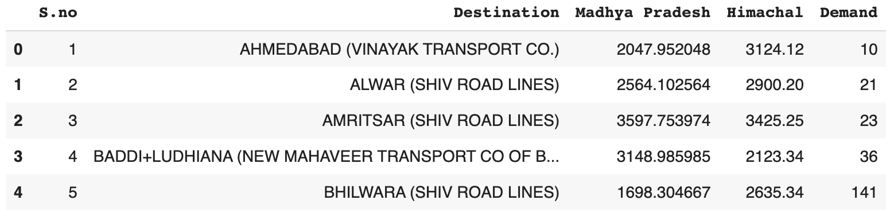

Table 7.1: df.head()

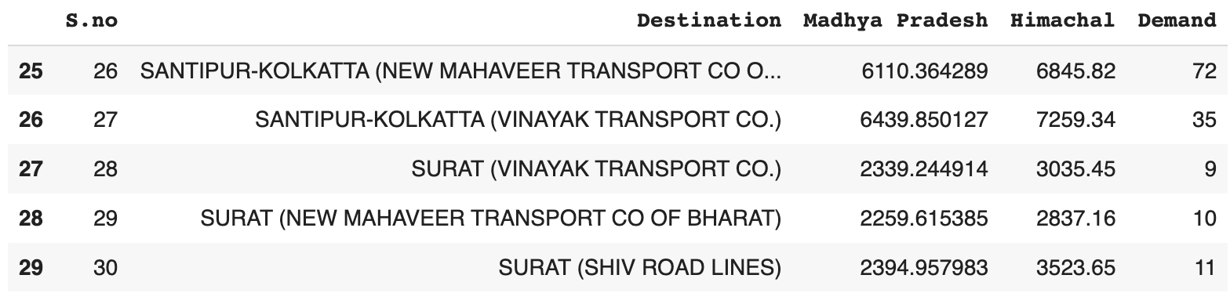

Table 7.2: df.tail()

Lists and dictionaries are created to represent the problem data.

**Branch** is a list of branches, **Warehouse** is a list of warehouses, **supply** is a dictionary that represents the supply available at each branch, **demand** is a dictionary that represents the demand at each warehouse, and **cost** is a dictionary of dictionaries that represents the transportation costs between branches and warehouses.

The PuLP problem object is created with the name "Transportation" and the objective of minimizing costs. The **LpProblem( )** function is used in the PuLP library to create a new optimization problem. It takes two arguments: the first argument is a string that represents the name of the problem, and the second argument is a constant that indicates the minimization problem (**LpMinimize**).

Further, a list of possible routes between branches and warehouses is created called **routes.**

a decision variable **x** using the **LpVariable( )** function from PuLP. The **dicts** method is used to create a dictionary of decision variables ‘**x’** with keys from the **Branch** and **Warehouse** lists, and an initial value of 0.

The objective function of the problem is defined using the **lpSum( )** function to sum the product of the decision variable ‘**x’** and the transportation cost ‘**cost’** for each possible route **(i,j)** in **routes.**

Constraints are created for each warehouse ‘**j’** and each branch ‘**i’** using the **lpSum( )** function to ensure that the total supply from all branches ‘**i’** to the warehouse ‘**j’** is equal to the demand for that warehouse and that the total supply from that branch to all warehouses is less than or equal to the supply available at the branch.

The **prob.solve( )** function starts the optimization process and find the optimal values of the decision variables that minimize or maximize the objective function, subject to the given constraints.

After calling solve( ), the **statu**s attribute of **prob** object will be updated through **LpStatus[ ]**, and the optimal solution can be accessed by calling the **value( )** function on the objective attribute of the prob object.

By performing the above-mentioned steps from the code, we get the following results:

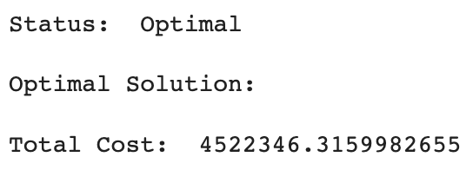

Figure 7.1: Optimal status and solution

Hence the solution obtained is an optimal solution.

Now since the optimal solution has been derived, our next step is to gain the possible combination of routes that give us the optimal solution along with their corresponding cost.

We start by creating an empty Python list called **results**. This list will be used to store the results of the optimization problem.

Then we append the data for each variable to the list. We loop through each possible combination of **i** in **Branch** and **j** in **Warehouse**. For each combination, we append a dictionary to the **results** list. The dictionary contains the values for the following keys:

* '**From**': the value of **i**
* '**To**': the value of **j**
* '**Quantity**': the optimized value of the decision variable **x[i][j]** (using the **.varValue** attribute of the variable)
* '**Cost**': the cost of shipping from i to j as defined in the **cost** dictionary.

Essentially, we create a list of dictionaries that stores the optimal values for each decision variable, along with the associated cost. Then we convert the resultant list to a Pandas dataframe called **df_results** with the help of **pd.DataFrame( )** function.

**pd.get_dummies( )**creates dummy variables for the **From** column in the **df_results** dataframe. This is done so that each branch has its own column in the final output, which makes it easier to read and analyze the results. Then we concatenate the **df_results** dataframe with the **df_from** dataframe, which contains the dummy variables for the **From** column by the help of **pd.concat( )** function.

Next, we use **.drop( )** function to drop the original **From** column from the **df_results** dataframe, since it is no longer needed after the dummy variables have been created. A new column to the **df_results** dataframe is added called **Total Cost**, which is calculated as the product of the **Quantity** and **Cost** columns.

We filter out the rows by removing any rows from the **df_results** dataframe where the **Total Cost** is 0, since these routes were not actually used in the optimal solution. We then reset the index of the **df_results** dataframe, since some rows may have been removed in the previous step.

Ultimately, we print the final **df_results** dataframe, which contains the details of the optimal shipping routes, including the quantity shipped, the cost per unit, and the total cost for each route. The dataframe is organized by branch and warehouse, with dummy variables used to represent each branch, making it easy to read and analyze the results.

Following is the result obtained:

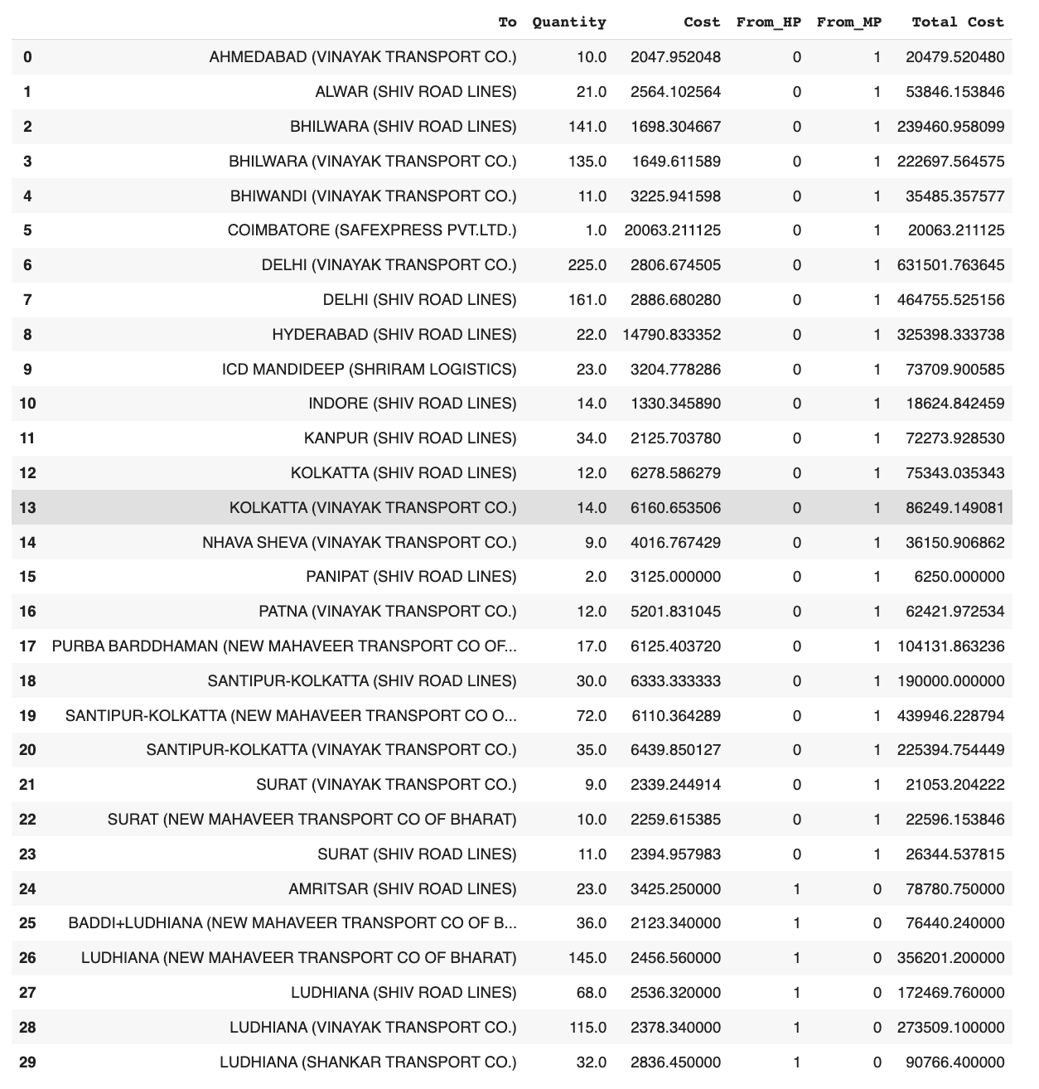

Table 7.3: Optimal shipping routes with corresponding cost and quantity

Based on the given result, it can be concluded that the optimal transportation plan for the given scenario involves transporting goods from the Branches (HP and MP) to the Warehouses at different locations across India. The "Quantity" column shows the amount of goods to be transported from each Branch to each Warehouse, while the "Cost" column shows the cost associated with transporting that quantity of goods from each Branch to each Warehouse. The "Total Cost" column shows the overall cost of transporting all the goods from all the Branches to all the Warehouses as per the optimal plan. It can be observed that the total cost is minimized by using a combination of different transportation routes from different Branches to different Warehouses, as determined by the optimization algorithm used in the model.

**Sensitivity Analysis**

Here, we initialize an empty list called **sensitivity_results**. This list will store the sensitivity results of the optimization problem. Then we start a loop that iterates over each constraint in the **prob** object. The loop is set up to extract the constraint name and the constraint object itself (**c**) using the **items( )** method of the **constraints** dictionary.

Inside the loop, we append a dictionary to **sensitivity_results**. The dictionary has two key-value pairs: '**Variable**' maps to the constraint name (**name**), and **'Shadow Price'** maps to the constraint's shadow price (**c.pi**), which is the amount by which the objective function would change if the right-hand side of the constraint is increased by one unit.

We iterates over all the variables in the optimization problem **prob** using a **for** loop. For each variable **v**, it checks if its name is in the constraint **c** using the **in** operator. If the name of the variable is in the constraint, it means that the variable is part of the optimal solution and has a non-zero dual value.

If the variable is part of the optimal solution, the code appends a dictionary to the **sensitivity_results** list. The dictionary contains two key-value pairs: Variable and Shadow Price. The **Variable key** holds a tuple with the variable name, the equality operator (**=**), and the variable value in the optimal solution (**v.varValue**). The **Shadow Price** key holds the dual value for that constraint (**v.dj**) which is the amount by which the objective function coefficient of the variable would need to change to make the variable enter or leave the optimal solution.

After the loops are finished, the **sensitivity_results** list is converted into a Pandas DataFrame called **df_sensitivity**. Each dictionary in **sensitivity_results** becomes a row in **df_sensitivity**.

A Series called **Destination** is created, which is a sorted list of the unique destination nodes in the **df_results** DataFrame. The **sort_values()** method sorts the values in ascending order, and the **reset_index()** method resets the index of the resulting Series to start from 0.

**pd.concat( )** function is used to concatenate **df_sensitivity** and **Destination** along the columns (axis=1), resulting in a new DataFrame with the sensitivity results in the first columns and the sorted destination nodes in the last column.

Finally, we filter the **df_sensitivity** DataFrame to remove rows where the shadow price is zero. This is because a zero-shadow price indicates that the corresponding constraint is not binding in the optimal solution, and therefore has no effect on the objective function value. Then we print the results out.

By applying sensitivity analysis, we get the following results:

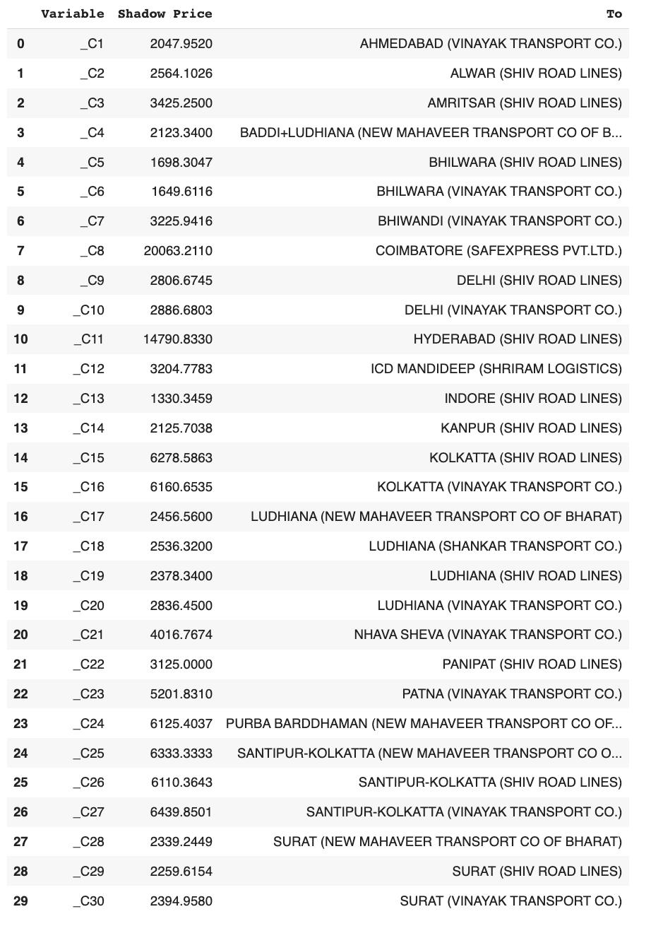

Table 7.4: Sensitivity analysis result

The sensitivity analysis results suggest that the optimal solution of the transportation problem is quite robust, meaning that it is not significantly affected by small changes in the supply and demand quantities, as well as the unit transportation costs.

The shadow prices associated with the constraints indicate the marginal value of increasing the supply or decreasing the demand at a particular origin or destination. If the shadow price for a particular constraint is high, it suggests that a small increase in the corresponding supply or decrease in the demand would result in a significant improvement in the total cost of transportation. Conversely, a low shadow price indicates that changing the supply or demand for that particular origin or destination would not significantly impact the total cost of transportation.

Overall, the sensitivity analysis results can provide valuable insights to decision-makers regarding the impact of changes in supply, demand, and costs on the optimal solution, and help them make more informed decisions.

**Conclusion**

Based on the shadow price values in the result, we can conclude that increasing the capacity of some constraints will have a greater impact on reducing the total transportation cost than others. For example, increasing the capacity of constraint C8, which represents transportation from Coimbatore, will result in the highest reduction in transportation cost, as the shadow price for this constraint is the highest at 20063.2110.

On the other hand, increasing the capacity of constraints such as C13 (Indore), C16 (Kolkata - Vinayak Transport Co.), and C28 (Surat - New Mahaveer Transport Co. of Bharat) will result in a relatively lower reduction in transportation cost, as their corresponding shadow prices are relatively lower than others.

Therefore, the conclusion is that increasing the capacity of constraints with higher shadow prices will result in a greater reduction in total transportation cost compared to increasing the capacity of constraints with lower shadow prices.

The company transported goods from both of their branches to all the destinations. With the help of the results obtained, the routes will be optimized to give better results.

**Sales Forecast**

We begin by importing the required libraries:

* The **pandas** library is used for data manipulation and analysis.
* The **numpy** library is used for numerical operations.
* The **matplotlib** libraries are used for data visualization.
* The **SARIMAX** model class from the "**statsmodels**" library, which is a Python library for time series analysis and modeling.
* The "**auto_arima**" function from the "**pmdarima**" library, which is a Python library for time series analysis and forecasting. The "auto_arima" function is used to automatically select the optimal parameters for an ARIMA model based on the input data.
* The "**mean_squared_error**" function from the "**sklearn**" library, which is a Python library for machine learning and data analysis. The "mean_squared_error" function is used to calculate the mean squared error between two arrays, which is a common evaluation metric for regression models.

The datasets are uploaded using the **pd.read_excel (**) function from the pandas library. The **'parse_dates'** parameter is used to convert the 'Date' column into a datetime format, and the **'index_col**' parameter is used to set the 'Date' column as the index of the DataFrame. Then the dataset is split into training and testing sets. The **'train_size**' variable is calculated as 80% of the length of the DataFrame, and then converted to an integer using the 'int' function. The 'train' DataFrame is created by slicing the 'df' DataFrame from the beginning up to the 'train_size' index. The 'test' DataFrame is created by slicing the 'df' DataFrame from the 'train_size' index to the end of the DataFrame. We used the **train.head()** and **test.head()** functions to confirm that the data was loaded correctly.

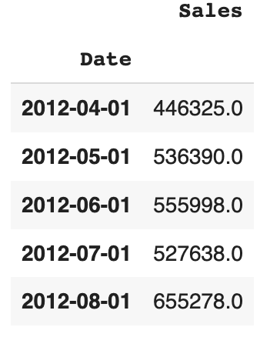

Table 7.5: train.head() Table 7.6: test.head()

the "**auto_arima**" function from the "**pmdarima**" library to automatically select the best parameters for a seasonal ARIMA (SARIMA) model based on the training data. The "**seasonal**" parameter is set to "**True**" to indicate that the data has a seasonal component, and the "m" parameter is set to 12 to indicate that the data has a monthly seasonality (i.e., the seasonality repeats every 12 months). The resulting model object is stored in the "**model**" variable.

The "**summary**" method of the model object is then called to print a summary of the model's parameters and performance which is as follows:

Figure 7.2: Model Summary

the "**fit**" method of the "**SARIMAX**" class from the "**statsmodels**" library is used to fit the SARIMA model to the training data.

The "**predict**" method of the "SARIMAX" class is applied to generate predictions for the test set. The "**n_periods**" parameter is set to the length of the **test** set to indicate that the model should generate predictions for each period in the test set.

Next we calculate the root mean squared error (**RMSE**) between the actual values in the test set and the predicted values generated by the SARIMA model. The "**mean_squared_error**" function from the "**sklearn**" library is used to calculate the mean squared error, which is then passed to the "**np.sqrt**" function from the "**numpy**" library to calculate the square root and obtain the RMSE.



Figure 7.3: RMSE calculated

The obtained value of RMSE is slightly higher than expected due to COVID which affected the sales of the company in the month of April-June drastically. This unexpected change caused the difference and therefore affected the value of RMSE.

Finally, we plot the actual, test and predicted values of the time series data.

* **plt.plot(train.index, train, label='Train')**: This plots the training data with the index values on the x-axis and the actual values on the y-axis. The label parameter is used to give a name to this plot in the legend.
* **plt.plot(test.index, test, label='Test')**: This plots the test data with the index values on the x-axis and the actual values on the y-axis. The label parameter is used to give a name to this plot in the legend.
* **plt.plot(test.index, test_pred, label='Predicted')**: This line plots the predicted values with the index values on the x-axis and the predicted values on the y-axis. The label parameter is used to give a name to this plot in the legend.
* **plt.legend()**: This adds a legend to the plot, which shows the labels assigned to each plot using the label parameter.
* **plt.show()**: This displays the plot.

Figure 7.4: Actual vs Forecasted sales

**Conclusion**

Based on the results, the SARIMA model with parameters (1, 1, 3)x(1, 0, [ ], 12) was found to be the best fit for the time series data. The model was able to capture the seasonal and temporal patterns in the data and generate accurate predictions for the test data. Keeping the covid anomaly aside, the RMSE value of the predictions was relatively low, indicating that the model had a good fit with the data.

The actual and predicted values were also plotted to visualize the performance of the model. From the plot, it is clear that the SARIMA model was able to generate accurate predictions for the test data, closely following the trends in the actual data.

In conclusion, the SARIMA model was able to effectively model the time series data and generate accurate predictions. This model can be used to forecast future values of the time series with a good level of accuracy.

**Appendix**

**Code for transportation Problem**

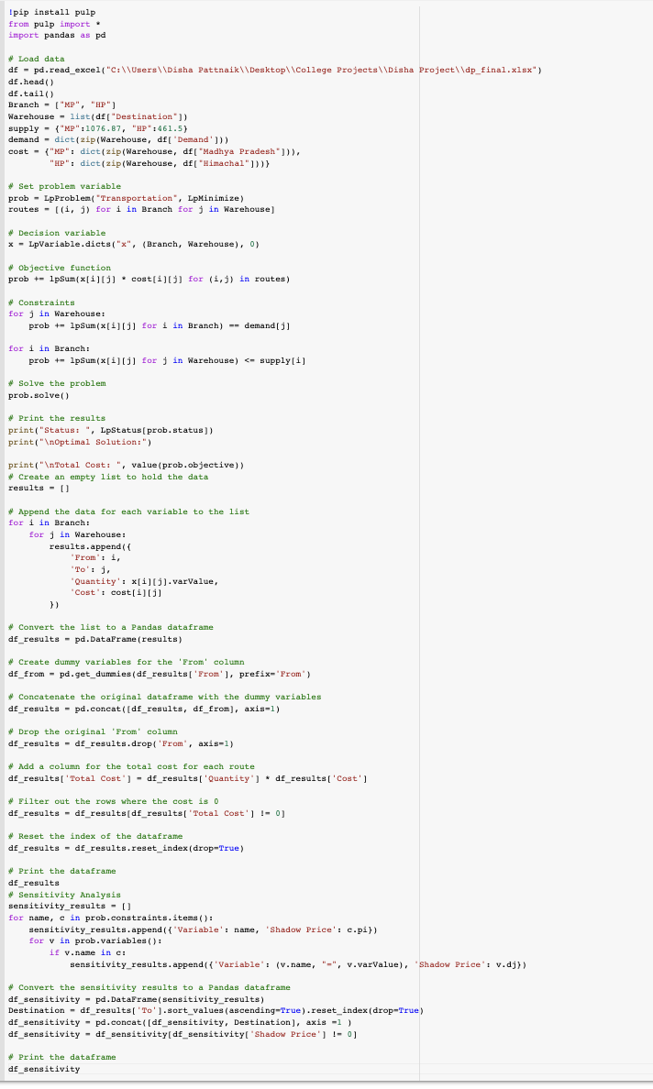

**Code for Sales Forecasting**

